**Web and Authentication server setup**

**Node js Setup:**

Install Node server using below link:

<https://nodejs.org/en/download/>

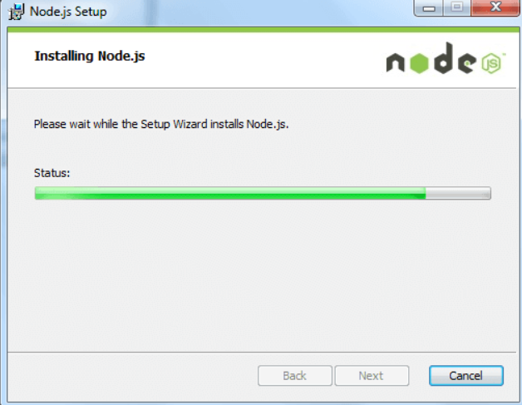

Check node version to check if it is installed.

Node –v

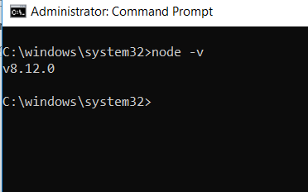

Install the dependencies by using below mentioned command:

Npm install

Start Node server:

node .\App.js

**Setup React web application:**

Node comes with node package manager.

Check version of npm.

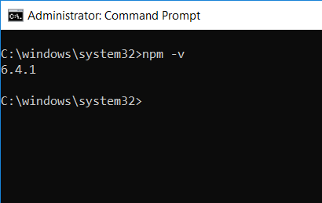

Install React Js globally using npm.

npm install -g create-react-app

npm install –g react

Start the web application using command:

**npm start**